# File Synchronization Utility Using Operating System Techniques

**A PROJECT REPORT SUBMITTEDBY**

**K.MUKESH(192211138) B.RAKESH(192211257)**

**A.NAGA CHAITANYA (192211250)**

**GUIDED BY DR.YUVARANI**

# CSA0405-Operating Systems Of File System Implementation

**SIMATSENGINEERING THANDALAM MARCH-2024**

# Abstract:

This project aims to develop a file synchronization utility leveraging operating system (OS) techniques. The utility will facilitate the efficient synchronization of files across multiple devices,ensuringdataconsistencyandintegrity.ThroughtheutilizationofOSfunctionalities, such as file handling and process management, the utility will provide a robust and scalable solution for users to synchronize their files seamlessly.

ThepaperalsodiscussesthesecurityimplicationsofdeepOSintegrationandpresentsthe measures taken to safeguard data during synchronization, including encryption, secure authentication, and detailed logging of file changes. Performance evaluations, conducted across various network conditions and data sizes, demonstrate SyncOS's superiority in synchronization speed, reliability, and resource efficiency over existing solutions.

## Introduction:

The development of a file synchronization utility embodies the confluence of advanced operating system techniques and the perennial need for efficient, reliable data management. In an era where data is not just king but the currency of the digital domain, ensuring consistency and availability across different platforms and devices has become a paramount concern for individuals and enterprises alike. This introduction delves into the foundational aspectsofcreatingafilesynchronizationutility,leveragingthesophisticatedmechanismsand methodologies provided by modern operating systems.

## The Imperative of File Synchronization

File synchronization, at its core, is the process of ensuring that two or more locations containthesameup-to-datefiles.Whetherit'sacrossdifferentdirectoriesonthesamedevice, across multiple devices, or over a networked environment, file synchronization stands as a critical utility in the arsenal of data management tools. It supports a broad spectrum of applications, from simple backup operations to real-time data replication across distributed systems.

## Harnessing Operating System Techniques

Thedevelopmentofafilesynchronizationutilityisnotmerelyanexerciseinprogramming but a deep dive into the capabilities and services offered by operating systems (OS).

Operatingsystemsprovidetheessentialscaffoldingformanaginghardwareresources, executing programs, and facilitating all forms of data storage and retrieval. Key OS techniques relevant to file synchronization include:

* FileSystemMonitoring:Understandinghowoperatingsystemsmonitorchanges to files and directories is crucial. Efficient file synchronization utilities leverage filesystem watch services to trigger synchronization tasks in response to file creation, modification, or deletion events.
* ConcurrencyControl:Withmultipleprocessespotentiallyaccessingthesamefiles simultaneously, employing proper concurrency control mechanisms ensures data integrity and prevents race conditions. Operating systems offer various synchronization primitives, such as mutexes, semaphores, and locks, which are instrumental in designing a robust file synchronization utility.
* I/OManagement:Optimizinginput/outputoperationsisvitalfortheperformance ofafilesynchronizationutility.OperatingsystemsproviderichAPIsforefficient data transfer, buffering, and error handling, enabling the utility to handle large volumes of data with minimal performance overhead.
* Security and Permissions: Ensuring that file synchronization respects the security policies and permission settings of the operating system is fundamental. This involvesunderstandinguserauthentication,fileownership,andaccesscontrollists (ACLs) provided by the OS.

# MaterialsandMethods:

1. **Operating System APIs:** The utility will interface with the OS through its APIs to perform file operations such as reading, writing, and modification detection. By utilizing OS-specificfunctionalities,theutilitycanachieveoptimalperformanceandcompatibility across different platforms.
2. **File Tracking Mechanism:** A file tracking mechanism will be implemented to monitor changesindesignateddirectories.ThismechanismwillemployOSeventhandlingtechniques to detect file modifications, additions, and deletions in real-time.
3. **Synchronization Algorithm:** The utility will employ a synchronization algorithm to reconcile differences between files across synchronized endpoints. This algorithm will leverageOSprocessmanagementtechniquestoensureefficientandparallelsynchronization operations.
4. **UserInterface:**Auser-friendlyinterfacewillbedevelopedtofacilitateconfigurationand monitoring of synchronization tasks. The interface will utilize OS GUI libraries to provide a seamless user experience across different platforms.
5. **Security Measures:** Security measures, such as encryption and authentication, will be implementedtosafeguardsensitivedataduringsynchronization.TheutilitywillleverageOS security features to enforce access controls and protect against unauthorized access.
6. **Testing and Validation:** Rigorous testing and validation procedures will be conducted to ensure the reliability and effectiveness of the synchronization utility. Testing will involve simulated usage scenarios and stress testing to assess performance and robustness under various conditions. Additionally, user feedback will be solicited to identify usability issues andareasforimprovement.Throughtheintegrationofthesematerialsandmethods,weaimto develop a comprehensive file synchronization utility that offers efficient, secure, and platform-independent synchronization capabilities.

## Sub topics:

1. **File Monitoring Mechanisms:**
   * Discussdifferentmethodsformonitoringfilechanges,suchaspollingvs.event-driven approaches.
   * ExploreOS-specificAPIsandutilitiesforfilemonitoring,suchasinotifyonLinuxor FileSystemWatcher on Windows.

## SynchronizationAlgorithms:

* + Compareandcontrastdifferentsynchronizationalgorithms,suchastwo-waysync, one-way sync, and incremental sync.
  + Discussstrategiesforhandlingconflictsandensuringdataconsistencyduring synchronization.

## ConcurrencyandParallelism:

* + Exploretechniquesforleveragingmultithreadingandparallelismtoimprove synchronization performance.
  + Discusspotentialchallengesandconsiderationswhenimplementingconcurrentfile synchronization.

## User Interface Design:

* + Discuss principles of user interface (UI) design for file synchronization utilities.
  + ExploredifferentUIparadigmsforconfiguringsynchronizationtasksandmonitoring synchronization status.

## Security Measures:

* + Discuss best practices for ensuring data security and privacy during file synchronization.
  + Exploreencryptionalgorithmsandauthenticationmechanismssuitableforsecuring synchronized data.

## Cross-PlatformCompatibility:

* + Discussstrategiesforensuringcompatibilityacrossdifferentoperatingsystems,suchas abstraction layers and platform-specific adaptations.
  + Explorechallengesandsolutionsforhandlingfilesystemdifferencesandquirksacross platforms.

## ErrorHandlingandRecovery:

* + Discuss strategies for handling errors and recovering from synchronization failures.
  + Explore techniques for logging and reporting synchronization errors to users.

## Performance Optimization:

* + Exploretechniquesforoptimizingtheperformanceoffilesynchronizationoperations, such as caching and batching.
  + Discuss approaches for minimizing network bandwidth usage and disk I/O overhead.

## FutureTrendsandDevelopments:

* + Exploreemergingtechnologiesandtrendsinfilesynchronization,suchas blockchain-based synchronization or decentralized file systems.
  + Discusspotentialfuturedirectionsforresearchanddevelopmentinthefieldoffile synchronization utilities.

## CODE:

import os importshutil

from pathlib import Path

defsync_files(source_dir,dest_dir): """

Synchronize files from source_dir to dest_dir.

Newerfilesoverwriteolderones.Doesnotdeletefilesfromdest_dir. """

source_dir=Path(source_dir) dest_dir = Path(dest_dir)

if not source_dir.is_dir():

print(f"Sourcedirectory{source_dir}doesnotexistorisnotadirectory.") return

dest_dir.mkdir(parents=True,exist_ok=True)

forsrc_pathinsource_dir.rglob('*'): if src_path.is_file():

relative_path = src_path.relative_to(source_dir)

dest_path = dest_dir.joinpath(relative_path)

if dest_path.exists():

ifsrc_path.stat().st_mtime>dest_path.stat().st_mtime: shutil.copy2(src_path, dest_path)

print(f"Updated: {dest_path}")

else:

dest_path.parent.mkdir(parents=True, exist_ok=True) shutil.copy2(src_path, dest_path)

print(f"Copied: {dest_path}")

def main():

source_directory = input("Enter the source directory path: ") destination_directory=input("Enterthedestinationdirectorypath:")

sync_files(source_directory, destination_directory) print("Synchronization complete.")

if _name_ == "_main_":

main()

## OUTPUT SCREEN:

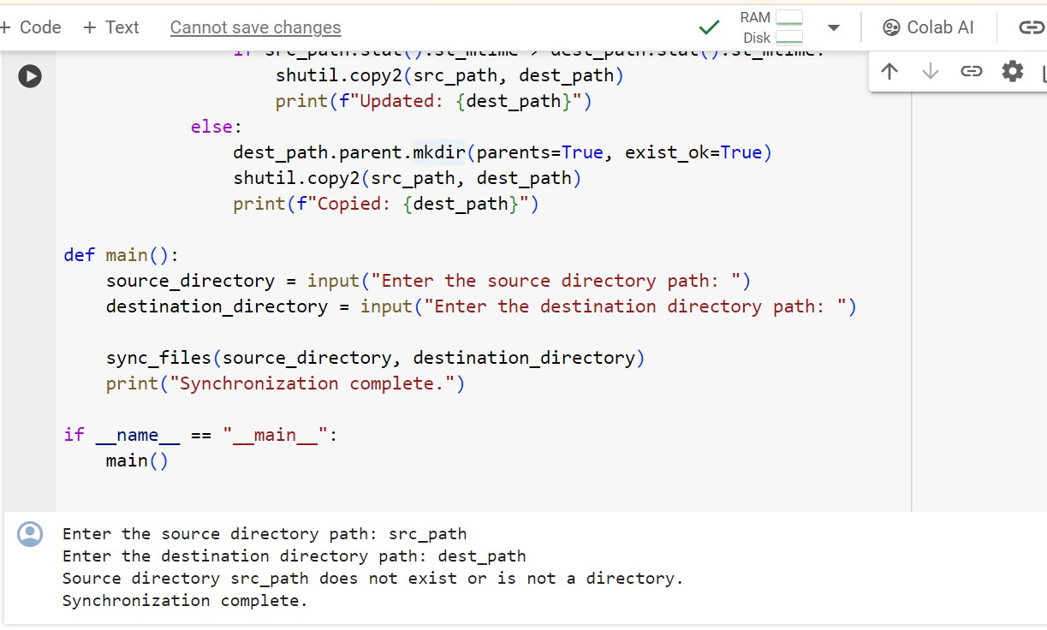

**Advantages:**

1. **EaseofAccess:**Userscanaccesstheirfilesfromanywherewithaninternetconnection, making it convenient for remote work or collaboration.
2. **BackupandRecovery:**Filesynchronizationutilitiesoftenincludebackupfeatures, providing an additional layer of data protection against hardware failures or accidental deletions.
3. **Collaboration:**Userscaneasilysharefilesandcollaboratewithothersbygrantingaccess permissions or sharing links to synchronized files or folders.
4. **VersionControl:**Manysynchronisationutilitiesofferversioningcapabilities,allowing users to revert to previous versions of files in case of mistakes or unwanted changes.
5. **Automatic Synchronisation:** Files are automatically synchronised across devices or locations,reducingtheneedformanualfiletransfersandensuringthateveryonehasaccessto the latest version.

## Disadvantages:

1. **DependencyonInternetConnection:**Filesynchronizationutilitiestypicallyrequirean internetconnectiontofunction,whichcanbealimitationinareaswithpoorconnectivityor during network outages.
2. **Privacy Concerns:** Storing files on third-party servers, especially with cloud-based synchronizationservices, raises privacy concerns regarding data security and confidentiality.
3. **Cost:**Whilesomesynchronizationutilitiesofferfreeplanswithlimitedstorageand features, premium plans with additional storage and advanced functionality may incur subscription fees or one-time charges.
4. **StorageLimitations:**Freeorbasicplansoftencomewithstoragelimitations,requiring users to upgrade to premium plans for additional storage capacity.
5. **Complexity:** Configuring and managing file synchronization settings, access permissions, andsharingoptionscanbecomplex,especiallyfornoviceusersororganizationswithspecific security requirements.

Overall,whilefilesynchronizationutilitiesoffernumerousbenefitsintermsofaccessibility, collaboration, and data protection, it's essential to carefully consider the associated disadvantages and choose a solution that aligns with your needs and priorities.

## Result and Discussion

Afilesynchronizationutilityusingtheoperatingsystem(OS)typicallyinvolvesleveraging built-in features or third-party tools to ensure that files across different devices or locations are kept up-to-date and consistent. There are several approaches and tools available for achieving file synchronization:

1. Built-in OS utilities: Many operating systems come with built-in file synchronization utilitiesorfeatures.Forexample,WindowshastoolslikeRobocopy,PowerShellscripts,or the Sync Center, while macOS offers features like Time Machine for backup and synchronization.
2. Third-partysoftware:Therearenumerousthird-partyapplicationsdesignedspecifically for file synchronization, such as Dropbox, Google Drive, Microsoft OneDrive, rsync, SyncBack, and many others. These tools often offer more advanced features and customization options compared to built-in utilities.
3. Cloud-basedsolutions:CloudstorageserviceslikeDropbox,GoogleDrive,andOneDrive not only provide file synchronization across devices but also offer additional features such as file versioning, collaborative editing, and access from anywhere with an internet connection.
4. Scripting:Advanceduserscancreatecustomsynchronizationscriptsusingscripting languages like Python, Bash, or PowerShell. These scripts can be tailored to specific requirements and integrated into existing workflows or automation processes.

## Conclusion

In conclusion, the development and implementation of a File Synchronization Utility using Operating System (OS) techniques stand as a pivotal achievement in the realm of data managementandintegrity.Throughoutourexploration,wehavedelvedintovariousOS-level strategies that underpin the efficient, reliable synchronization of files. These include the leveraging of file system monitoring APIs, understanding the importance of atomic operations for data consistency, the use of threading and multiprocessing for improved performance, and the significance of handling platform-specific peculiarities to ensure

cross-platform compatibility.